**CHAPTER 1**

**INTRODUCTION**

The world in 21st centuries is growing up in every field of technology such as education, medicine, transport and so on, the use of technology makes the world so faster and easier than the early world and it releases the world from manual usage in every field. In the early days manual usage caused many mistakes by the user and administrative. Using manual properties in the fields was not comfortable for the consumers, because it was slower than technical usages, caused wastages of the consumers’ time and contained many formalities in usage. Information and database system projects are initiated to improve the accuracy of the processing data and to ensure the procedure prescribing how to do a specific task. A computer program can maintain accurate and consistent database hence it gives improved performance. The program efficiency increased considerably by including automatic calculations and fast data retrieval capabilities. This will dramatically reduce the manual error and permit more study at lower cost and effort. The Zoological Park is situated Bengaluru, Karnataka in India and it is very rich in terms of animal diversity, especially for mammals and insects. The park is using manual entry and record keeping for their administration, maintenance and ticket entry fields. Using computerized programs for the above fields is easy to maintain whole data in user friendly way. According to the basic needs of programs for this zoological park, this research was carried out to make the ZMS for works easier.

The program efficiency increased considerably by including automatic calculations and fast data retrieval capabilities. This will dramatically reduce the manual error and permit more study at lower cost and effort. The Zoological Park is situated Bengaluru, Karnataka in India and it is very rich in terms of animal diversity, especially for mammals and insects. The park is using manual entry and record keeping for their administration, maintenance and ticket entry fields. Using computerized programs for the above fields is easy to maintain whole data in user friendly way. According to the basic needs of programs for this zoological park, this research was carried out to make the ZMS for works easier. Using manual properties in the fields was not comfortable for the consumers, because it was slower than technical usages, caused wastages of the consumers’ time and contained many formalities in usage.

**CHAPTER 2**

**SOFTWARE REQUIREMENT**

**SPECIFICATION**

The software and hardware requirements are very important to be generally required to the system and work is being done in accordance to the matter for designing a particular computer architecture, the power of central processing unit is a fundamental requirement for the computer, to be used in a very alternatively manner it’s important to work in an orderly manner that can be generally categorized and worked with increasing demand for high processing power and resources of attest versions with increasing over a period of time.

**2.1 Software Requirements**

1. Operating System : Windows 10 home
2. Front End : XAMPP
3. Back End : phpMyAdmin
4. Browser : Google Chrome

**2.2 Hardware Requirements**

1. CPU : INTEL CORE i3 8th Gen processor
2. Memory : 1 GB
3. Cache : 2 MB
4. Floppy Disk : 1.44MB
5. Hard Disk : 80 GB
6. Speed : 2.2GHZ

**CHAPTER 3**

**SYSTEM ANALYSIS**

**3.1 Existing System**

* Not User Friendly

The existing system is not user friendly because the ticket booking process is very slow and data is not maintained efficiently.

* Manual control

All calculations to generate report are done manually so there is greater chance of errors.

* Time consuming

Every work is done manually so we cannot give the ticket in the middle of the session or as per the requirement because it is very time consuming.

**DISADVANTAGES OF EXISTING SYSTEM**

* Difficult to buy the tickets
* Not User Friendly
* Manual control
* Lots of paperwork
* Time consuming
* Low level security
* Low level accuracy and efficiency

**3.2 Proposed System**

Our proposed system is an automated format of the above Slated paper-based work. Here the entire process is computerized thus by reducing the man power and the entire manual work. This system provides a computerization method for the organization can easily handle their particular details. It’s very easy to maintain ticket and animal details. This system consumes less amount of timing, so avoiding the people standing on the long queue. This system minimizes the paperwork load. The admin can manage the animal records by adding, updating, removing and viewing for details of the animals. Talking about the features of the system the tickets can be issued and also the ticket records can be managed easily without any use of pen and paper. Apart from this, the visitor can view a list of the animals currently present inside the zoo.

The system helps in handling the records with great ease. Sometimes if there is a need for information of a particular ticket details no need to search in huge heap of files resulting in wastage of time and effort. The system overcomes such issues and reduces a lot of pen paper work. The system stores the data in a database for future retrieval purposes.

The admin can manage the animal records by adding, updating, removing and viewing for details of the animals. Talking about the features of the system the tickets can be issued and also the ticket records can be managed easily without any use of pen and paper. Apart from this, the visitor can view a list of the animals currently present inside the zoo.

**ADVANTAGES OF THE PROPOSED SYSTEM**

* User Friendly to access.
* Tickets are easily generated.
* Very less paper work.
* Computer operator control.
* Time consumption is low
* This system provides High level security.
* Efficiency level is higher than the existing system.
* Tickets are easily generated.
* Very less paper work.
* Computer operator control.
* Time consumption is low
* This system provides High level security.
* User Friendly to access.
* Efficiency level is higher than the existing system.
* Tickets are easily generated.

**CHAPTER 4**

**SYSTEM DESIGN**

**System design** is the process of designing the elements of a system such as the architecture modules and components, the different interfaces of those components and the data that goes through that system.

**Elements of a System**

* **Architecture**- This is the conceptual model that defines the structure, behaviour and more views of a system. We can use flowcharts to represent and illustrate the architecture.
* **Modules -**This are components that handle one specific tasks in a system. A combination of the modules makes up the system.
* **Components -**This provides a particular function or group of related functions. They are made up of modules.
* **Interfaces -**This is the shared boundary across which the components of the system exchange information and relate.
* **Data -**This the management of the information and data flow.

**4.1 Water Fall Model**

Waterfall model is the pioneer of the SDLC processes. In fact, it was the first model which was widely used in the software industry. It is divided into phases and output of one phase becomes the input of the next phase. It is mandatory for a phase to be completed before the next phase starts. In short, there is no overlapping in Waterfall model. In waterfall, development of one phase starts only when the previous phase is complete. Because of this nature, each phase of waterfall model is quite precise well defined. Since the phases fall from higher level to lower level, like a waterfall, it is named as waterfall model.

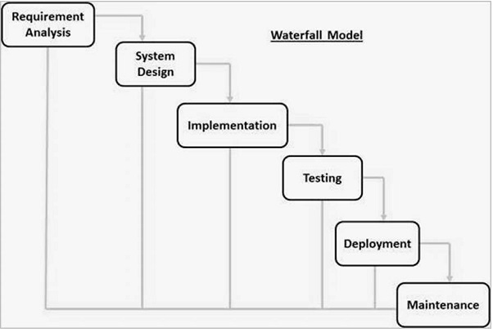

**FIG 1: WATER FALL MODEL**

**4.2 DATABASE DESCRIPTION**

**4.2.1 Microsoft SQL Server**

The overall objective in the development of the database technology has been to treat data as an organizational resource and as an integrated whole. Database management system allows data to be protected and organize separately from other resources. Database is an integrated collection of data. The most significant of data as seen by the programs and data as stored on the direct storage access storage devices. This is the difference between logical and physical data. The organization of data in the database aims to achieve free major objectives:

## Data Integration

## Data Integrity

## Data Independence

The proposed Management Information System stores the information relevant for processing in the phpMyAdmin Database. This phpMyAdmin is a free software tool written in [PHP](https://php.net/), intended to handle the administration of [MySQL](https://www.mysql.com/) over the Web. phpMyAdmin supports a wide range of operations on MySQL and MariaDB.

Frequently used operations (managing databases, tables, columns, relations, indexes, users, permissions, etc) can be performed via the user interface, while you still have the ability to directly execute any SQL statement phpMyAdmin comes with a wide range of [documentation](https://www.phpmyadmin.net/docs/).

**4.3 SOFTWARE INTERFACE DESCRIPTION**

**4.3.1 XAMPP SOFTWARE**

XAMPP is a free and open-source cross-platform web server solution stack package developed by Apache Friends, consisting mainly of the Apache HTTP Server, MariaDB database, and interpreters for scripts written in the PHP and Perl programming languages. Since most actual web server deployments use the same components as XAMPP, it makes transitioning from a local test server to a live server possible.

XAMPP's ease of deployment means a [WAMP](https://en.wikipedia.org/wiki/WAMP) or [LAMP](https://en.wikipedia.org/wiki/LAMP_(software_bundle)) stack can be installed quickly and simply on an operating system by a developer. Though it is a heavy app for most of the operating systems even when owing to its less size it takes a load on the processor speed. The most obvious characteristic of XAMPP is the ease at which a [WAMP](https://en.wikipedia.org/wiki/WAMP) webserver stack can be deployed and instantiated.Later some common packaged applications that could be easily installed were provided by [Bitnami](https://en.wikipedia.org/wiki/Bitnami" \o "Bitnami).

Officially, XAMPP's designers intended it for use only as a development tool, to allow website designers and programmers to test their work on their own computers without any access to the Internet. To make this as easy as possible, many important security features are disabled by default. XAMPP has the ability to serve web pages on the [World Wide Web](https://en.wikipedia.org/wiki/World_Wide_Web).

Xampp Control panel is used to start the Apache server and the MySQL which is required to run the website in the local host.

It is very important to note down the things after clicking on the start buttons beside the Apache and MySQL modules:

* Attempting to start Apache app
* Status change detected running
* Attempting to start MySQL app
* Status change detected running

If all the above points are noted then surely the default browser will open and it can be concluded that everything is running as it is supposed to.

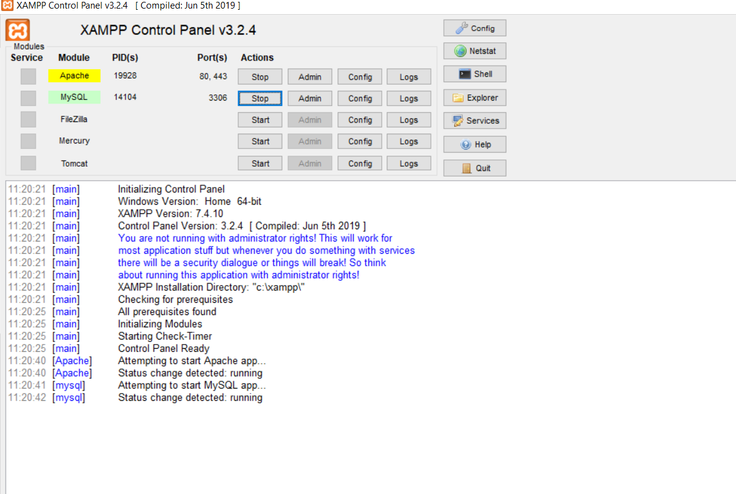

**FIG 4.2: XAMPP CONTROL PANEL**

**4.5 IMPLEMENTATION MODULES**

**4.5.1 System Implementation**

System implementation is the process of bringing the developed system and turning it over to user. It can be the most crucial stage in achieving a successful new system and in giving the users confidence that the new system will work and be effective.

**Implementation plan**

For successful implementations of the system, implementation plan is necessary. Its major elements include test plan, training plans, an equipment installation plan and a conversion plan. The test plan provides for the preparations of the test ad for testing the system in a planned, structured manner. Training plan is necessary to ensure that all people who are associated with the computer related information system have the necessary knowledge and skills. The important activities are preparations, equipment installation and hardware –software checkout.

Conversion is the process if initiating and performing all the physical operations that result directly in the turnover of the new system to the user.

There are two parts of conversion. The conversion plan is implemented throughout the development phase into the operational phase. The conversion plan includes procedural conversion, program conversion and the file conversion. The changeover plan also specifies the method of change from old to new system.

**4.5.2 Input Design**

Input design is the process of converting user-originated inputs to a computer-based formats. Input data are collected and organized into groups of similar data. Once identified, appropriate data are selected for processing the input forms are designed using GU controls. So, error may be avoided. The inputs are:

1. **LOGIN FORM:** This form is used by the Admin to login to the system using correct username and password. Thus, it provides security to the system. It also has the provision to change the password of the user who has currently logged in.
2. **ANIMAL DETAILS:** This module allows the admin check the animals, modify the details of the animals and add new animals to the zoo.
3. **MANAGE TICKETS:** This is the most important module of because it deals with the ticket details. There are two different types of tickets present normal and foreigner tickets. Here ticket details can be managed also tickets can be booked. There are two different types of tickets present normal and foreigner tickets. Here ticket details can be managed also tickets can be booked.
4. **REPORTS:** This module allows the admin generate the reports between the range in terms of date.It will generate the reports between the dates specified. In this way the week, month, quarter, semi-annual and annual reports can be generated.
5. **SEARCH TICKETS:** This form allows search tickets for the admin in the system. It needs just one entry that is the unique ticket id. Also if the entire ticket id is not provided only a few digits present in it is provided in the correct sequence as it was in ticket id then also the search operation happens and it will display the details of the ticket matching with the provided ticket id.

**CHAPTER 5**

**SOFTWARE TESTING**

**5.1 SYSTEM TESTING**

The testing phase is an important part of software development. It is the processes of finding errors and missing operations and also a complete verification to determine whether the objectives are requirements are satisfied. Software testing is carried out in three steps.

The first step includes unit testing where in each module is tested to provide its correctness, to determine any missing operations and to verify whether the objectives have been met. Errors are noted down and corrected immediately. Unit testing is the important and major part of the project. So, errors are rectified easily in particular modules and program quality is increased. In this project, entire system is divided into several modules. In validation testing if user wants to enter the numeric value he can only enter the numeric value not the text value. For e.g.: in phone number field user can only enter numeric value to it. The system is user friendly with user guide and messages to explain further procedures. An attempt has been made to perfect the process by incorporating validation at each level.

Second step include integration testing. If we need not be the case that software whose modules when run individually and showing perfect result with also show perfect result as whole. The individual modules are clipped under this major module and tested again and verified the results. A module can have inadvertent, adverse effect on any other on the global data structure causing serious problems.

Levels in testing:

1. Unit testing
2. Integration testing
3. Validation testing

**5.1.1 UNIT TESTING**

It is the process of taking each program modules and runs in isolation from the rest of the modules, by using prepared inputs and comparing the results with the results predicted by the specifications and design of modules. This enables the tester to detect errors in coding and logic that are contained within that module one.

**5.1.2 INTEGRATION TESTING**

Integration testing is a systematic technique for constructing tests to uncover errors associated within the interfaces. In this testing, all the modules are combined, and then the entire program is tested as a whole.

**5.1.3 VALIDATION TESTING**

At the culmination of integration testing, software is completely assembled as a package; interfacing errors have been recovered and corrected and a final series of a software tests-validation tests begin. Validation testing can be defined in many ways but a simple definition is that validation succeeds when the software functions in a manner that can be reasonably expected by the customer. In validation testing if user wants to enter the numeric value he can only enter the numeric value not the text value. For e.g.: in phone number field user can only enter numeric value to it. The system is user friendly with user guide and messages to explain further procedures. An attempt has been made to perfect the process by incorporating validation at each level.

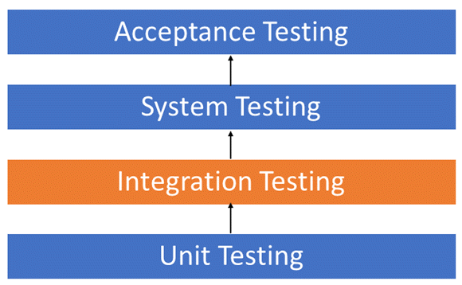

**FIG 5.1: VALIDATION-TESTING**

**CHAPTER 6**

**SNAPSHOT AND DESCRIPTION**

**6.1 HOME PAGE**

The below Snapshot 1 is of Home Page of the application. Here we find the following options on the header:

• Home

• About

• Contacts

• Animals

•Admin

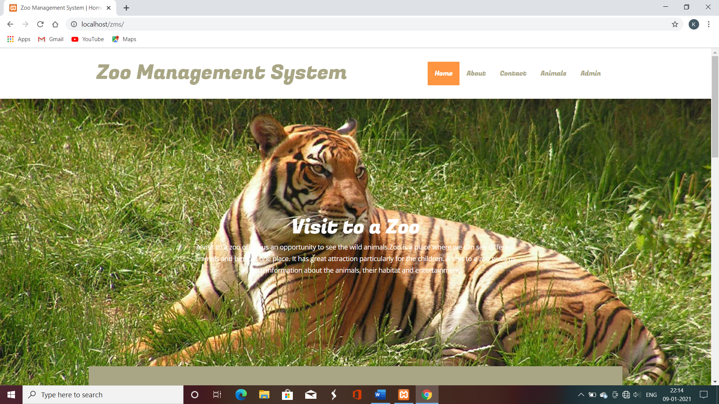

**Snapshot 1: Home Page**

**6.2 TIMING PAGE**

The below Snapshot 2 is of Home Page of the application. Here we find the seasonal timings of opening and closing of zoo as well as a small view of gallery.

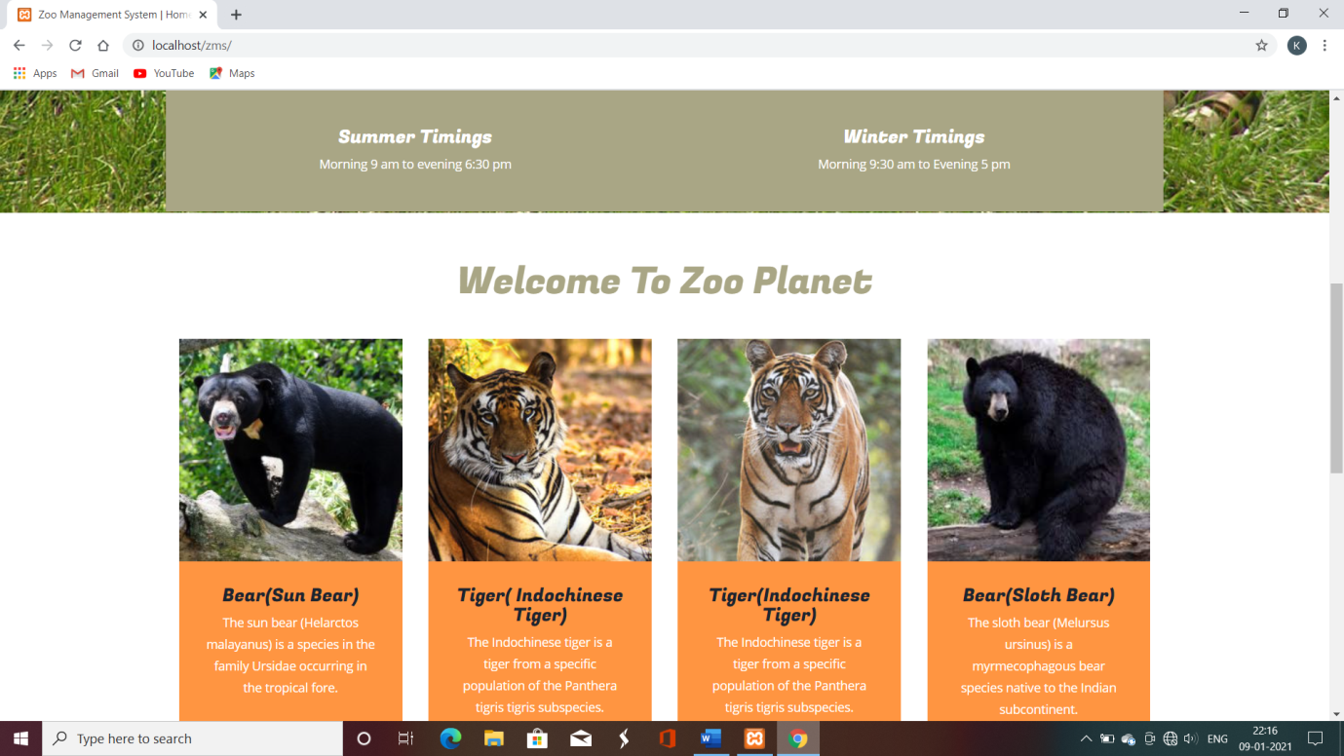

**Snapshot 2: Timing Page**

**6.3 FOOTER PAGE**

The below Snapshot 3 is of Footer page of the application. In this page visitors can find following options:

* Details
* Contact
* Social

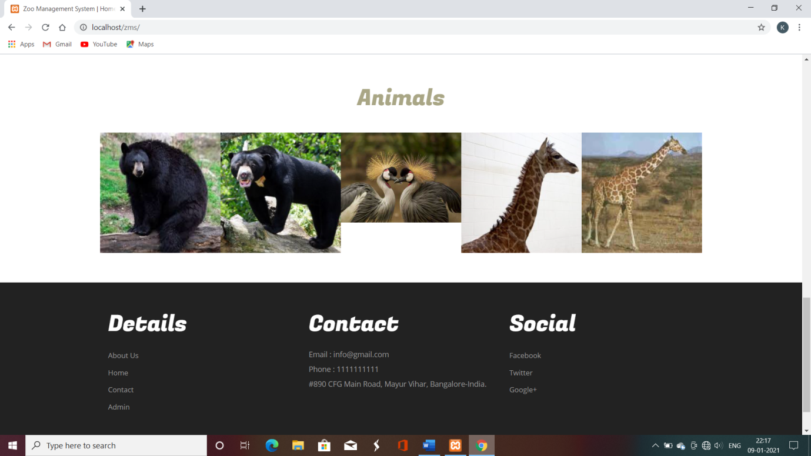

**Snapshot 3: Footer Page**

**6.4 ABOUT US PAGE**

The below Snapshot 4 shows the about us page which describes the information and key features of the zoo. It potrays the details as in when the zoo was formed, geographical location, etc.

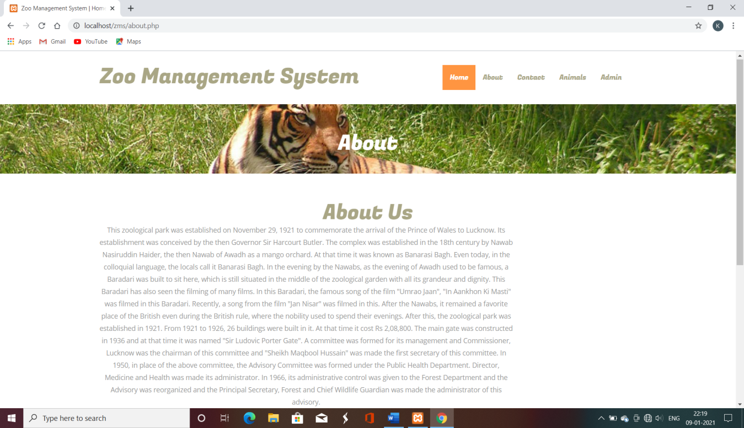

**Snapshot 4: About Us Page**

**6.5 ANIMAL DETAILS PAGE**

The below Snapshot 5 is the Animals Details page for the Zoo where there are following fields:

* Tigers
* Giraffe
* Elephants
* Bear
* Birds
* Reptile
* Lions
* Monkeys
* Alligators

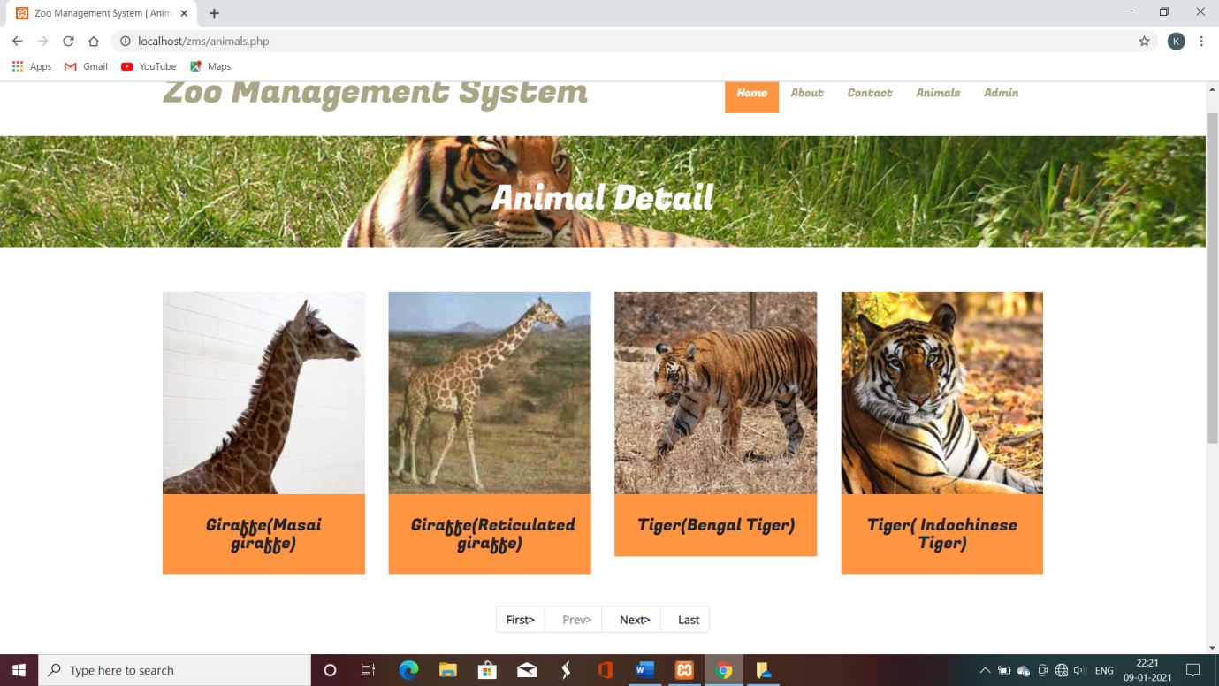

**Snapshot 5: Animal Details Page**

**6.6 ADMIN PAGE**

The below snapshot 6 displays the admin page where in the dashboard the admin can see the visitors of the current and previous and glance through it. It has several options on the left side of the screen.

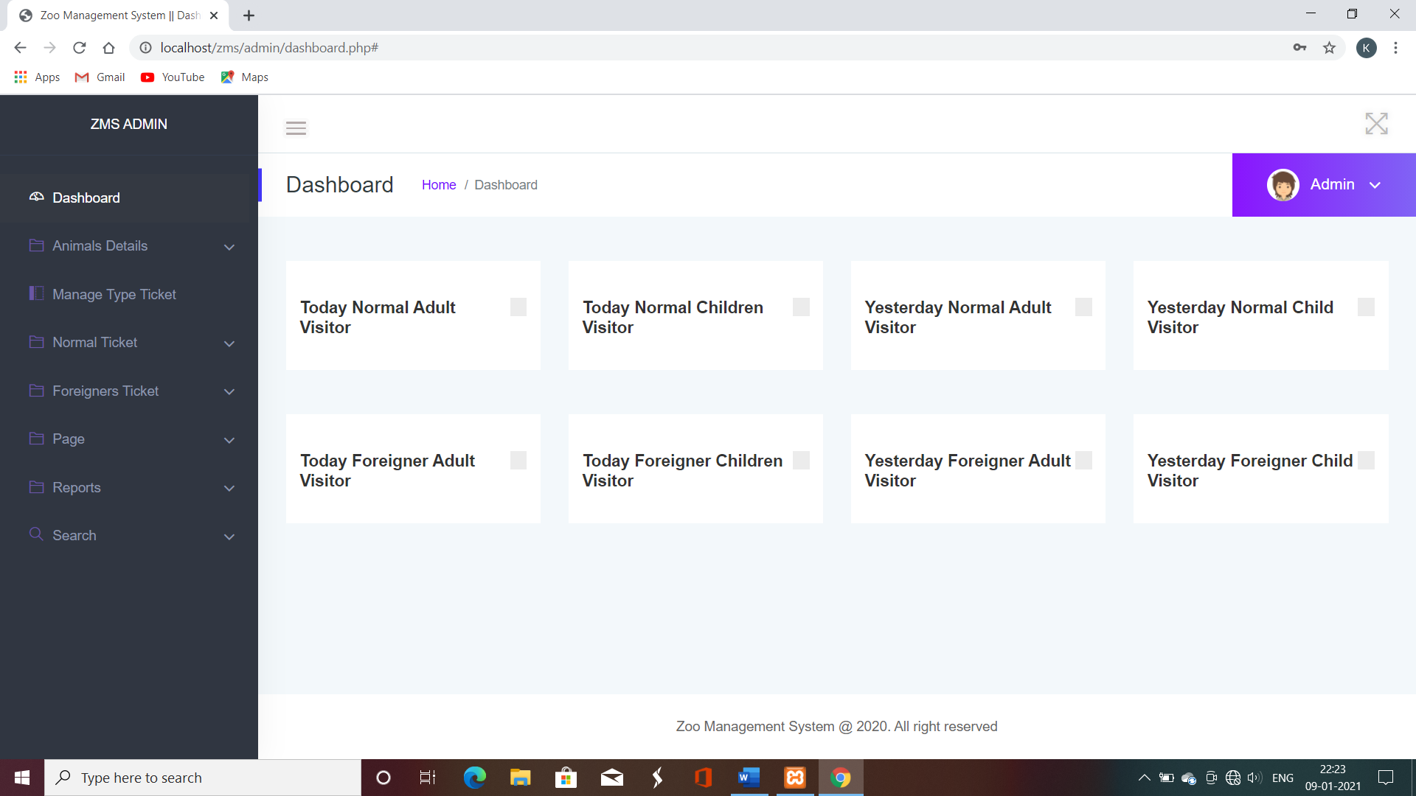

**Snapshot 6: Admin Page**

**6.7 TICKET PAGE**

The below Snapshot 7 is the ticket booking page where the number of persons and the total amount can be seen. The ticket id and the visiting is also displayed at the top.

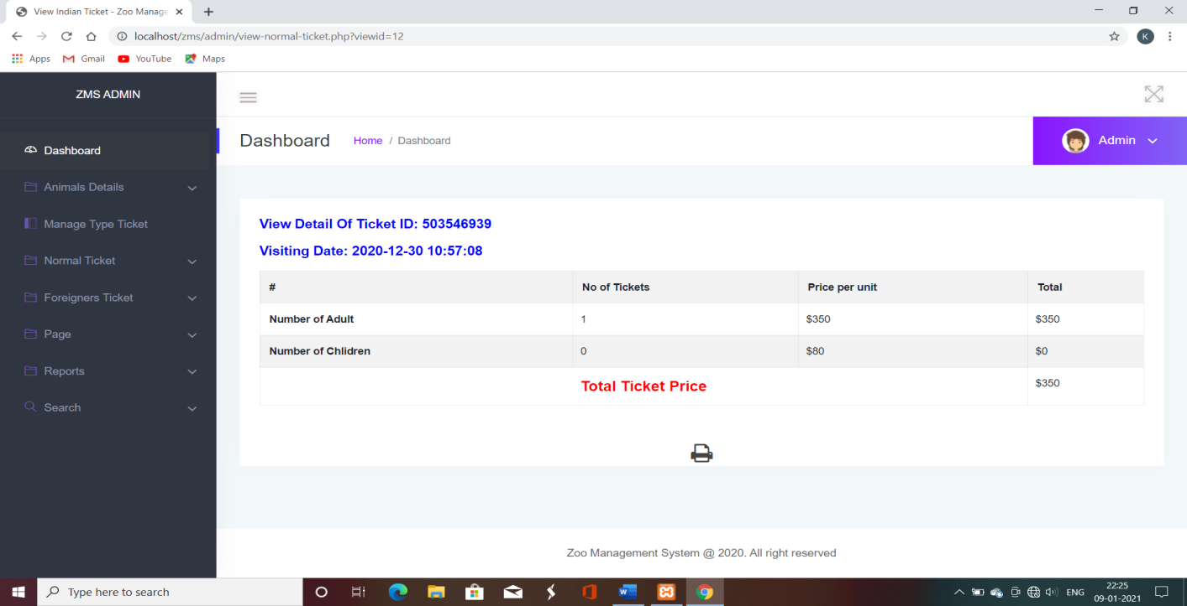

**Snapshot 7: Ticket Page**

**6.8 PRINTING TICKET PAGE**

The above Snapshot 8 is of printing the ticket where the ticket’s printout can be taken and number of copies can also be stated.

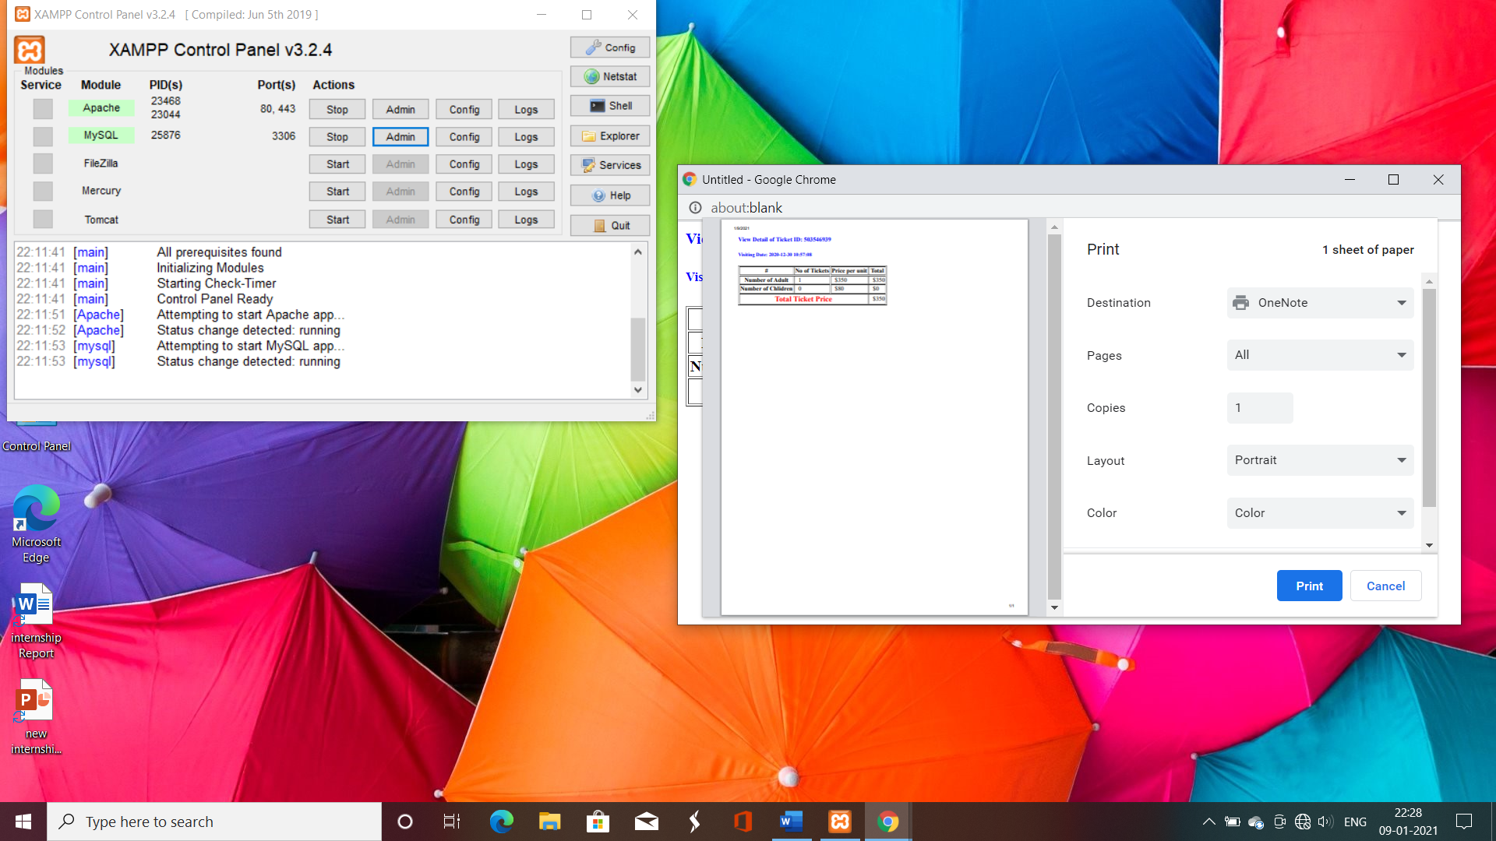

**Snapshot 8: Printing Ticket Page**

**6.9 TICKET REPORTS PAGE**

The below Snapshot 9 is the ticket report page between dates specified. It will generate the report of the tickets in the range of dates provided by the user.

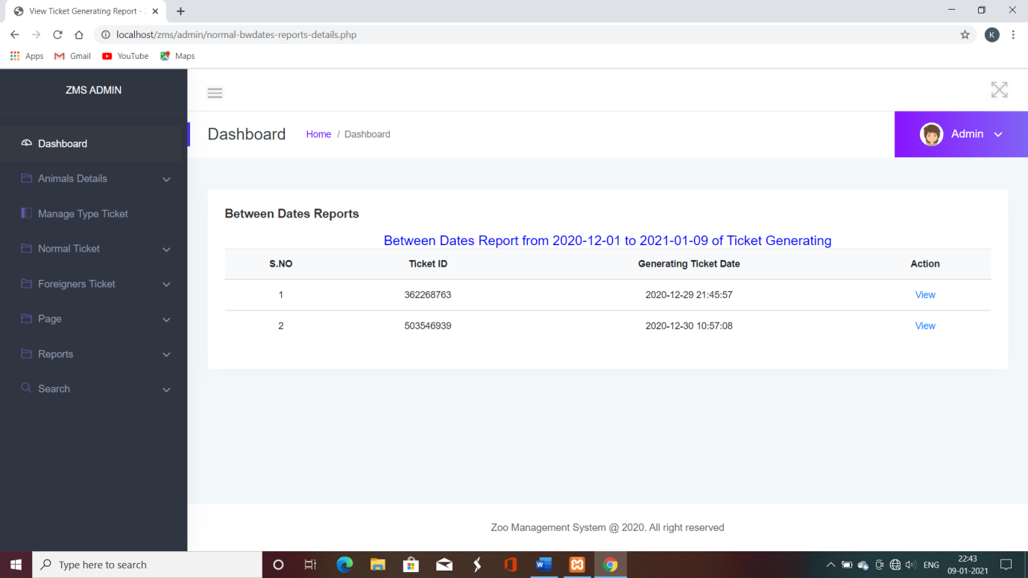

**Snapshot 9: Ticket Report Page**

**6.10 TICKET SEARCH PAGE**

The below Snapshot 10 is of ticket search by providing the ticket id. Every ticket has its own unique ticket id using which the ticket search can be made. If only starting few digits are provided then also the search operation can happen.

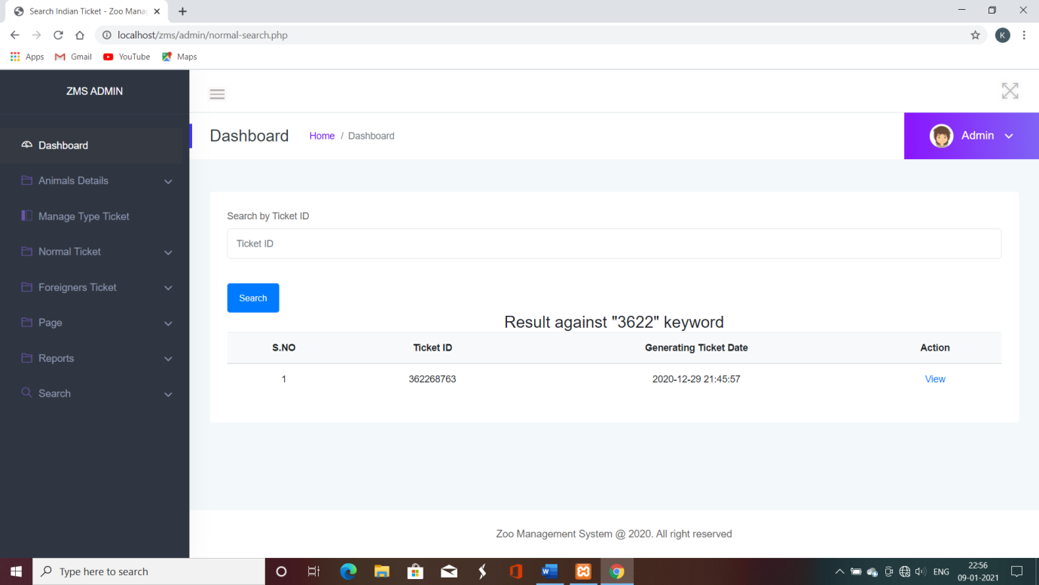 **Snapshot 10: Ticket Search Page**